Map Live Demo Script

1. Request a ride from SUB to WEM
   1. Start: 8900 114 st. Edmonton
   2. End: WEM Edmonton
2. Zoom in Start point
   1. It will be a lot easier to zoom in on a real device using gesture
3. Driver cannot go through the one-way road – why not start from ETLC building?
   1. Start: ETLC Edmonton
   2. Long Click – Drag to the entrance of the building (Intersection)
4. A driver lives in West Edmonton and he wants to go home after class at ETLC.
   1. Drag to Windsor Car Park (maybe he park there)  
      (1. Move up; 2. Drag exactly to the right half of “W”)
   2. Click the one with $10.45 to view addresses of start and end points

Prepare for Questions:

1. Why do you want to use Google Map?
   1. According to an Internet research, around 80% websites are using Google Map

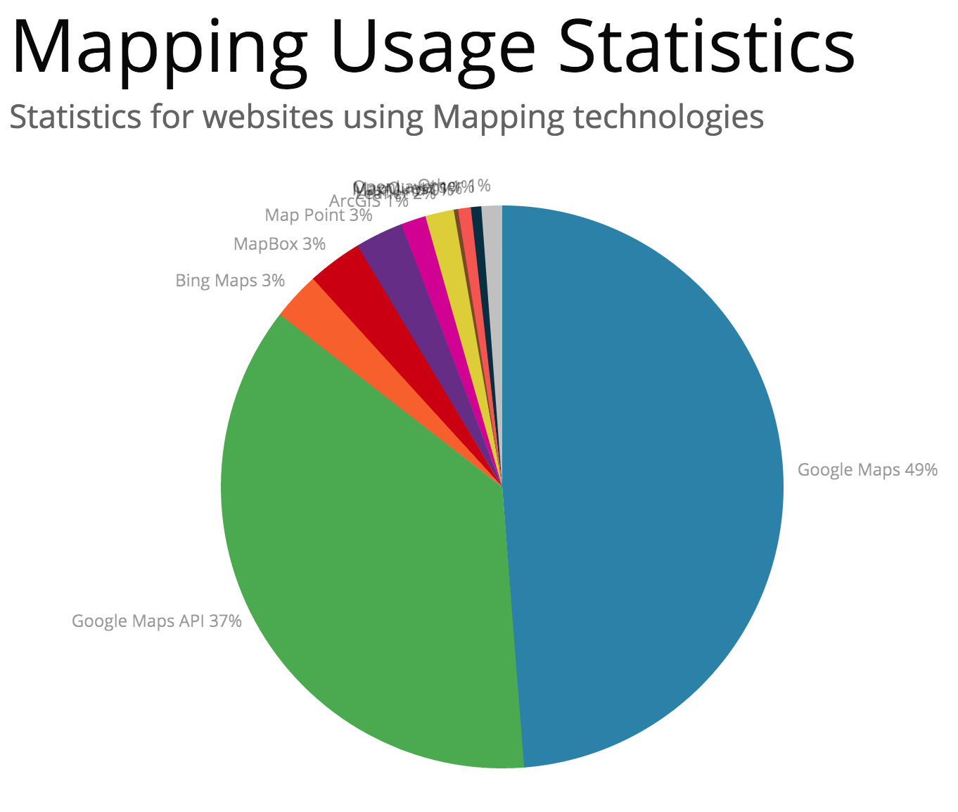

* 1. There must be a reason why so many people and companies are using it.
  2. Easy to search location based on address and keywords.

1. How can you do better?
   1. I will try to implement getting current location, which I have already been able to implement on high SDK.
   2. Get the distance directly from Google Map return instead of using Manhattan distance.